Table of Contents

**int_talkable**

Salesforce Commerce Cloud  
Integration Guide

1. Summary 3

2. Component Overview 4

2.1. Functional Overview 4

2.2. Use Cases 4

2.2.1. Invite Campaign 4

2.2.2. Advocate Dashboard Campaign 5

2.2.3. Reward Gleam Campaign 6

2.2.4. Leaderboard Campaign 7

2.2.5. Tiered Rewards Campaign 8

2.3. Limitations, Constraints 9

2.4. Compatibility 9

2.5. Privacy, Payment 9

3. Implementation Guide 9

3.1. Setup 10

3.1.1. Deploying cartridge to a sandbox 10

3.1.2. Sandbox setup 11

3.2. Configuration 12

3.3. Custom Code 14

3.4. External Interfaces 15

3.5. Testing 15

4. Operations, Maintenance 15

4.1. Data Storage 15

4.2. Availability 15

4.3. Support 15

5. User Guide 15

5.1. Roles, Responsibilities 15

5.2. Business Manager 15

5.3. Storefront Functionality 15

6. Known Issues 16

7. Release History 16

# Summary

Talkable is changing the way e-commerce companies acquire and retain customers, through one of the most powerful marketing tools—referrals. Refer-a-friend programs allow businesses to acquire new customers through the endorsement of their friends and family, shared via email, SMS, and other social channels.

This document describes how to implement the Talkable cartridge into the Salesforce Commerce Cloud site. The Talkable cartridge is a self-contained cartridge that can easily integrate into any Salesforce Commerce Cloud project. The cartridge can be configured in the Business Manager and contains all elements necessary to perform successful best practice implementation of Talkable.

After the cartridge is deployed, configured and integrated with the storefront templates, the customer will have the full power of Talkable marketing programs applied to their site.

In order to use the Talkable integration, you will need to contact Talkable before installing. Please reach out to [sales@talkable.com](mailto:sales@talkable.com) for details.

# Component Overview

## Functional Overview

Talkable enables your Salesforce Commerce Cloud store to attract new customers by offering them special deals in exchange for sharing with their friends.

This cartridge provides links for Advocates to share on Facebook, Twitter, and Email and encourages them to bring in new customers for you.

Using Talkable, you help your customers drive more referral sales per dollar than traditional marketing and advertising.

## Use Cases

Talkable can be used to create referral marketing campaigns of different types.

### Invite Campaign

Invite campaigns are powerful and versatile. They increase the number of new customers by giving anyone an opportunity to invite their Friends from various high traffic locations on the website as well as outside the website. You can set up multiple Invite campaigns to run simultaneously.

 *Invite Campaign.*

### Advocate Dashboard Campaign

The Advocate Dashboard campaigns provide Advocates a great insight on each of their shares as well as their associated rewards. Advocates are motivated to share more to achieve more rewards and can do that directly from their Dashboards.

  
*Advocate Dashboard Campaign.*

### Reward Gleam Campaign

The Reward Gleam improves the on-site conversion rate by assisting Friends and Advocates in using their coupons to purchase. When the Friend or Advocate gets a reward and goes to your website, the Reward Gleam captures the coupon code and displays it in a highlight bar at the bottom of the page. This type of campaign focuses on both Friends and Advocates and can be the perfect addition to any of your other campaigns.

 *Reward Gleam Campaign.*

### Leaderboard Campaign

The Leaderboard turns your campaign into a competition and inspires the Advocate to share more to get to the top of the leaderboard. You can easily detect your top performers and have special rewards for them.

 *Leaderboard Campaign.*

### Tiered Rewards Campaign

The Tiered Rewards campaign allows you to encourage Advocates gradually by tiering the rewards. The Advocates are incited to continue sharing after they receive the first reward in order to achieve the higher value one.

*  
Tiered Rewards Campaign.*

## Limitations, Constraints

The installation of the Talkable cartridge alone does not grant usage of Talkable. Every store must register for a Talkable plan to gain access to cartridge functionality. Please reach out to [sales@talkable.com](mailto:sales@talkable.com) for details.

## Compatibility

This cartridge is designed for Salesforce Commerce Cloud API 18.1. Compatibility Mode: 16.2.

## Privacy, Payment

Using Talkable binds you to the following [terms of service](https://www.talkable.com/terms).

Please read our [privacy policy](https://www.talkable.com/privacy) to understand how Talkable protects the information it collects.

Payment details are discussed on a per client basis and can be determined by reaching out to [sales@talkable.com](mailto:sales@talkable.com)

# Implementation Guide

Prerequisites

Before performing the steps in this document, ensure that you and your organization have satisfied the following criteria:

* You have reached out to Talkable and have obtained a Talkable Site ID to properly configure the Talkable cartridge. Talkable will create the required setup for the different campaigns (required by you) from Talkable’s client admin. Talkable will provide you the login credentials for client admin, where you can see and manage the different settings related to the campaigns activated for you.
* You have downloaded and unzipped the Talkable cartridge ZIP file from Salesforce Commerce Cloud Marketplace or your Talkable Technical Consultant. The cartridge ZIP file contains the Talkable cartridge package, which resides in the folder int_talkable, as well as the file talkable_settings.xml, which contains Talkable custom site preferences.

## Setup

### Deploying cartridge to a sandbox

1. Import the Talkable cartridge to a workspace in Salesforce UX Studio.

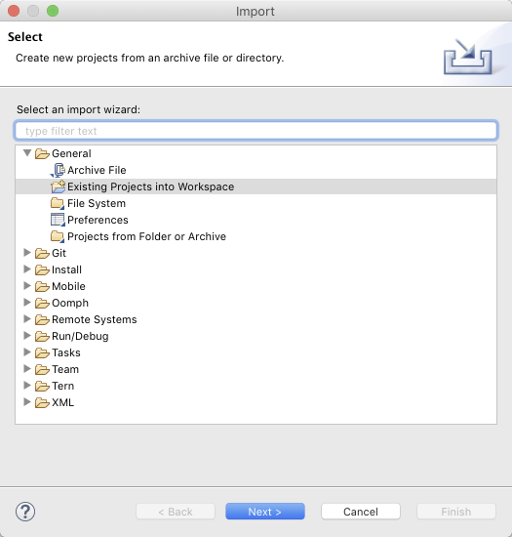

1. Attach the Talkable cartridge to the Digital Server Connection.

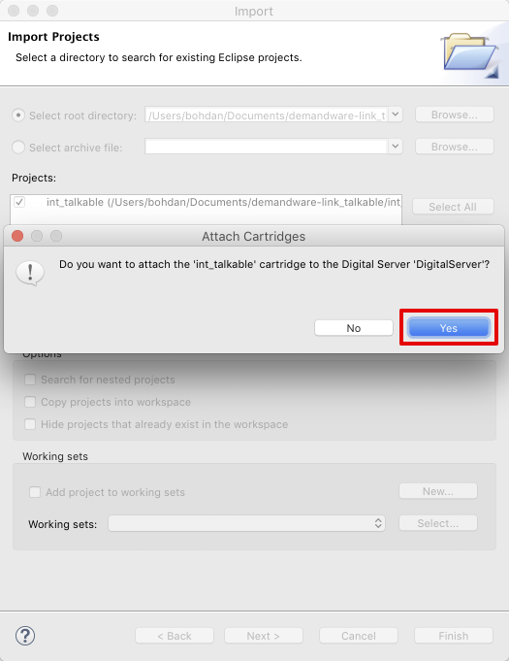

1. Wait until Studio completes workspace built and uploading of source codes to a sandbox.

### Sandbox setup

1. Go to Business Manager → Administration → Sites → Manage Sites. Select correct site, then select Settings tab. In the cartridge path at the end, write the following:

:int_talkable

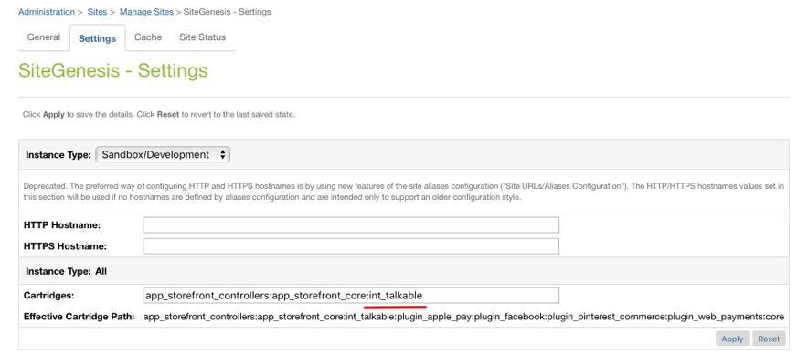

1. Open the folder where you extracted the Talkable cartridge ZIP file, and find talkable_settings.xml in folder Metadata.
2. Go to Business Manager → Administration → Site Development → Import & Export. Click Upload button and select talkable_settings.xml.

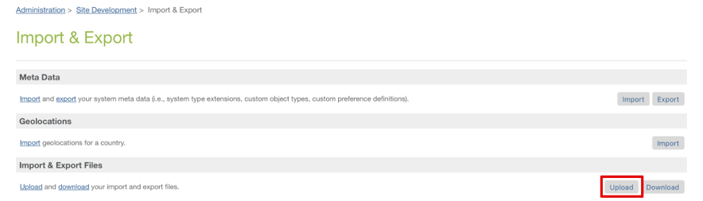

1. Click Import button and select talkable_settings.xml.

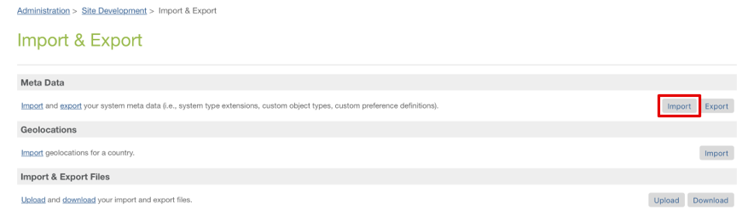

1. Go to Merchant Tools → Site Preferences → Custom Preferences. Verify that Site Preferences group was created with ID – *talkable* and name – *Talkable*.

## Configuration

This section describes configuration of the sandbox.

1. Go to Merchant Tools → Site Preferences → Custom Preferences → Talkable.

* Add site preference attribute – Talkable Site ID with provided Site ID from Talkable.
* Enable attribute – Post Purchase Campaign.
* Enable attribute – Invite Campaign.
* Enable attribute – Advocate Dashboard Campaign.
* Enable attribute – Floating Widget Popup Campaign.

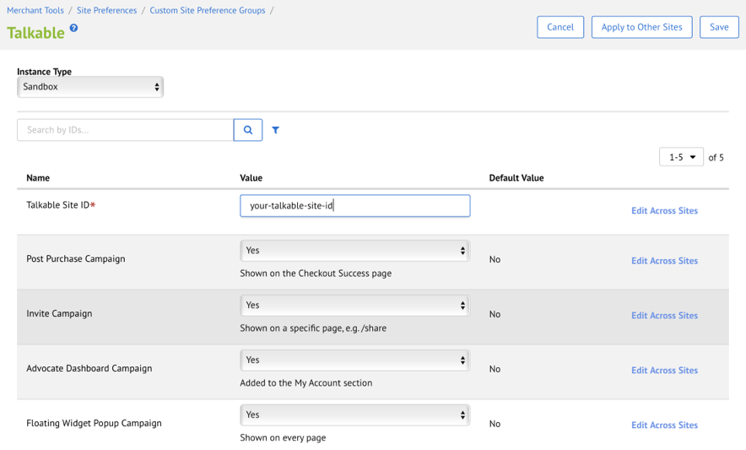

1. Go to Merchant Tools → Site URLs → URL Rules, then select Pipeline URLs tab.

Add the following rules:

* *share* resolves to *Talkable-Standalone*
* *referral-dashboard* resolves to *Talkable-Dashboard*

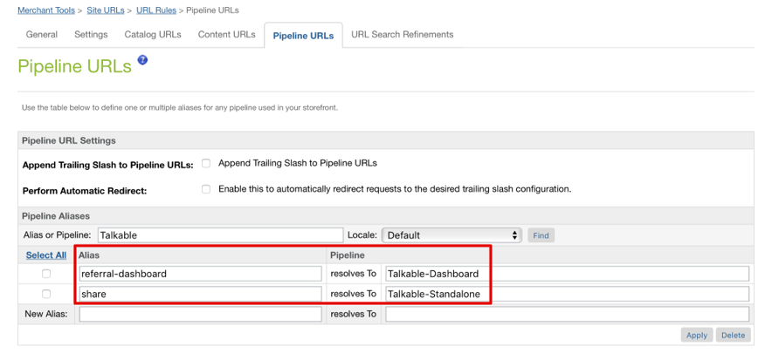

1. For the Advocate Dashboard Campaign to be shown in the My Account section, a small change required in the *account-nav-registered* content asset.

* Navigate to Merchant Tools → Content → Content Assets.
* Search for the *account-nav-registered* content asset.
* Lock the content asset in order to be able to edit it.
* Go to the body attribute and add the following line to the list of My Account section (please also check the screenshot below):

<li><a title="Referral Dashboard"

href="$httpsUrl(Talkable-Dashboard)$">Referral Dashboard</a></li>

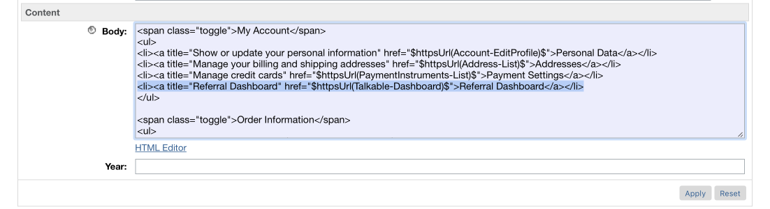

## Custom Code

This section describes changes that should be made to a merchant storefront cartridge.

1. Find and open the below template:

*storefront*/cartridge/templates/default/components/header/htmlhead.isml

Paste code at the end:

<isinclude url=*"${URLUtils.url('Talkable-Head')}"*/>

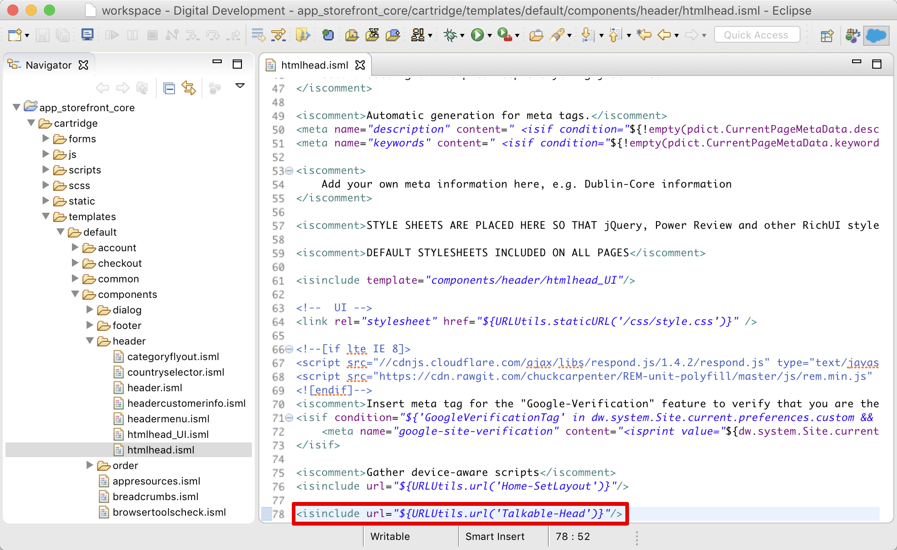

1. Find and open the below template:

*storefront*/cartridge/templates/default/checkout/pt_orderconfirmation.isml

Paste code before the closing </body> tag:

<isinclude template=*"talkable/post_checkout"*/>

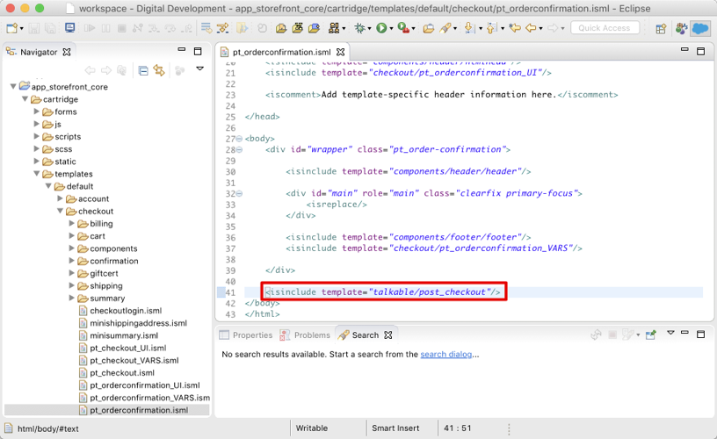

## External Interfaces

Talkable integrates with Salesforce Commerce Cloud Platform through JavaScript calls to Talkable API. All outside traffic from Salesforce Commerce Cloud instance is handled by HTTPS protocol.

Talkable integration documentation – <http://docs.talkable.com/integration/custom_integration.html>

## Testing

For a complete list of test cases, please refer to the test cases document.

# Operations, Maintenance

## Data Storage

*Intentionally left blank.*

## Availability

The Talkable platform is expected to be available 24/7. However, if something should happen and Talkable does not respond, the user will not be able to see Talkable campaigns. During that time, the user will see a blank screen instead of Standalone and Advocate Dashboard campaigns. If there is a problem connecting to Talkable, the functionality and performance of your site will not degrade in any way.

## Support

For technical support please contact your Talkable contact, or for cartridge specific questions you may email [support@talkable.com](mailto:support@talkable.com)

# User Guide

## Roles, Responsibilities

The store admin needs to follow setup instruction to add the Talkable cartridge, code, and configuration to make sure the integration will work properly. There are no recurring tasks that need to be fulfilled to set up the Talkable cartridge. As long as the configuration details are correct in your Site Preferences based on instructions in section 3.1, 3.2 and 3.3, then that is all that needs to be done.

## Business Manager

*Configuration options described above, in 3.2.*

## Storefront Functionality

*Intentionally left blank.*

# Known Issues

*Intentionally left blank.*

# Release History

|  |  |  |
| --- | --- | --- |
| **Version** | **Date** | **Changes** |
| 17.1.0 | June 9, 2017 | Initial release |
| 18.1.0 | June 8, 2018 | Second release – Bug fixes and improvements |